1. **INTRODUCTION**
   1. **Overview**

Retailer purchase goods or service from wholesalers or suppliers and sell to the consumers. They are known as the link between suppliers and final consumers. So, retailing is an act of obtaining products from wholesalers and selling to the ultimate users. There are several benefits as well as some limitations of retailing which are discussed in this post.

* 1. **Purpose**

*Ideal retail management systems should ensure the customer is satisfied with her shopping experience and should be able to shop with no difficulty.*

**2 Problem Definition & Design Thinking**

2.1 Empathy Map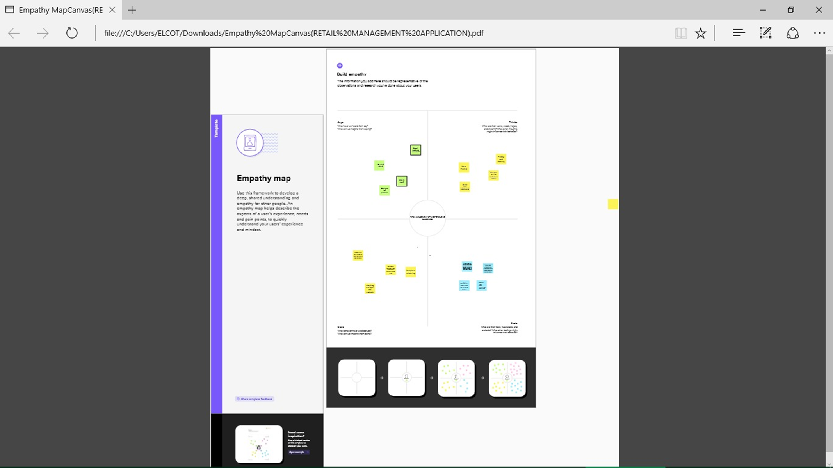

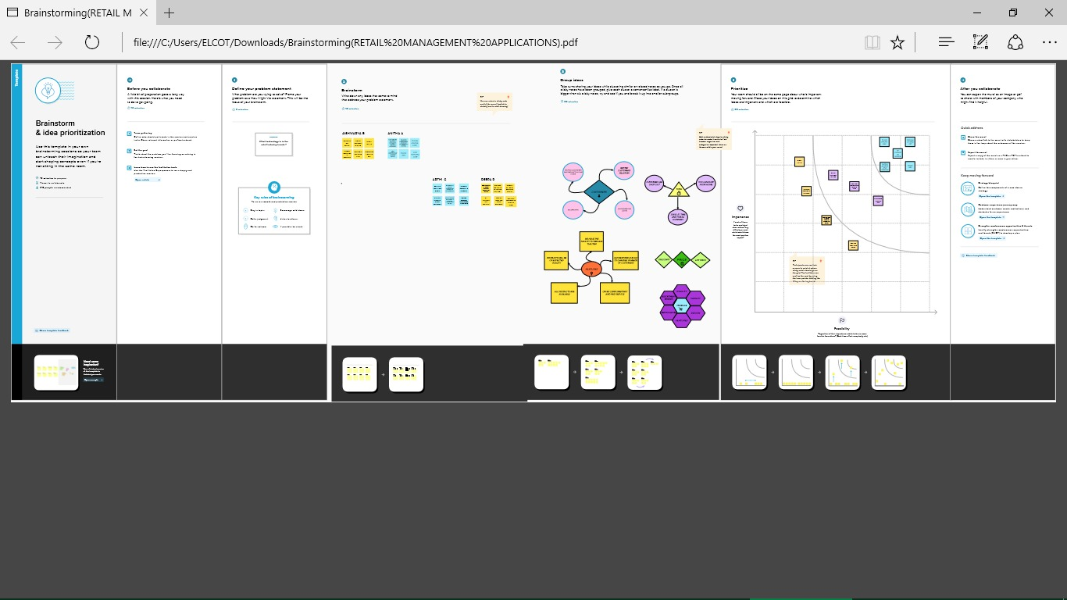

2.2 Ideation & Brainstorming Map



**3 RESULT**

3.1 Data Model:

|  |  |
| --- | --- |
| Object name | Fields in the Object |
| Display | |  |  | | --- | --- | | Field label | Data type | | Display | Text | |
| Tracking | |  |  | | --- | --- | | Field label | Data type | | Tracking | Text | |

**3.2 Activity & Screenshot**

**Milestone-1 (Description)**

**Activity -1**

In this milestone we are create developer account

**Milestone -2 Object:**

We do promotions by using this object .We capture stocks data and here we store product details that is electronic types.

**Activity -1**

We create object like dispatch or tracking

**Activity-2**

In this activity we are create the fields available on dispatch

**Milestone-3 Relationship between objects:**

**In this milestone we create relationship between object.**

**Milestone -4 Application**

Apps in Salesforce are a group of tabs that help the application function by working together as a unit. It has a name, logo and a particular an app is a collection of items that work together to serve a particular function Salesforce apps come in two app

**Milestone-5 Layouts:**

In this milestone we are create custom tabs

**Milestone-6 User:**

In this we describe about the process of user

**Milestone-7 Validation Rules:**

Validation rules verify that the data a user enters in a record meets the standards you specify before the user can save the record.

**Milestone-8 Dashboards:**

A dashboards a way of displaying various types of visual data in one place .Usually, a dashboard is intended to convey different but related information in an easy-to-digest form.

**Milestone-1 :**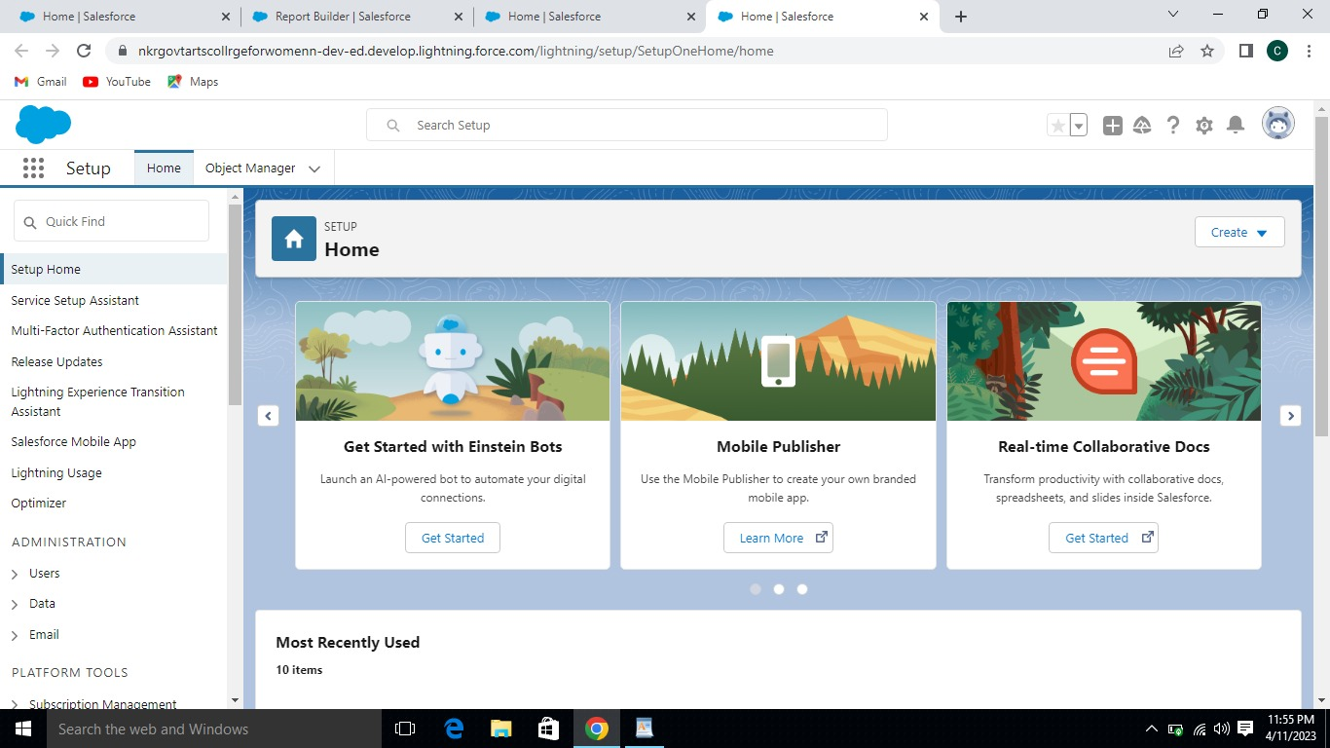

**Milestone-2 Objects**

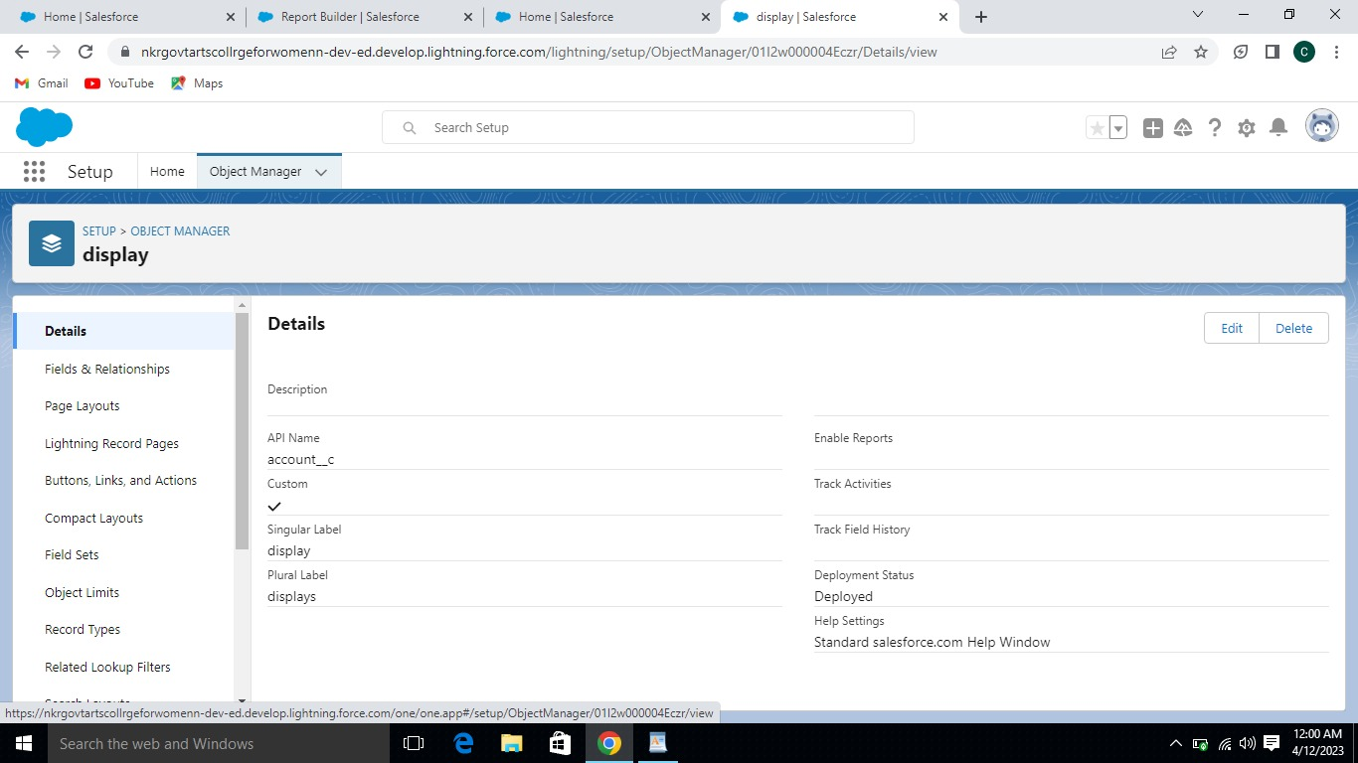

**Activity -2 Fields available on Dispatch/tracking**

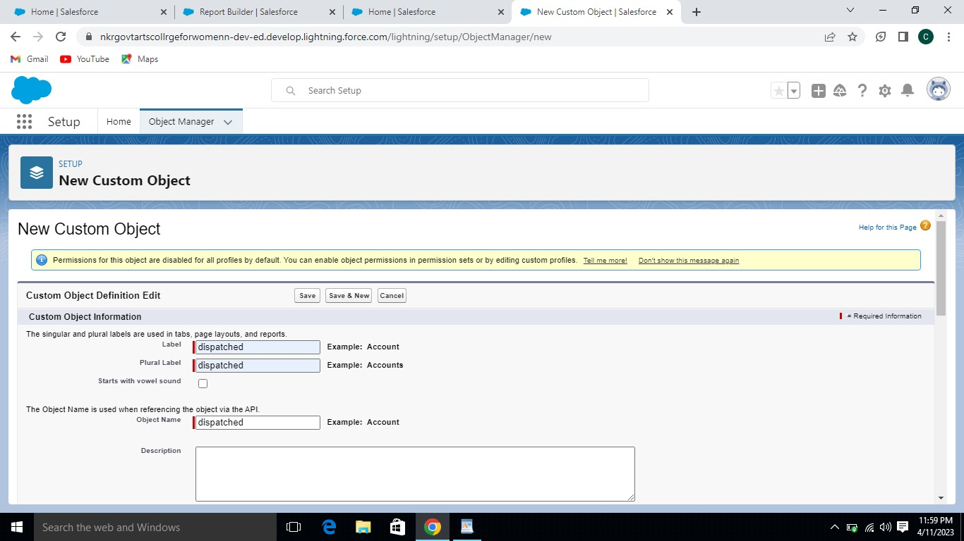

**Milestone-3 Relationship between objects:**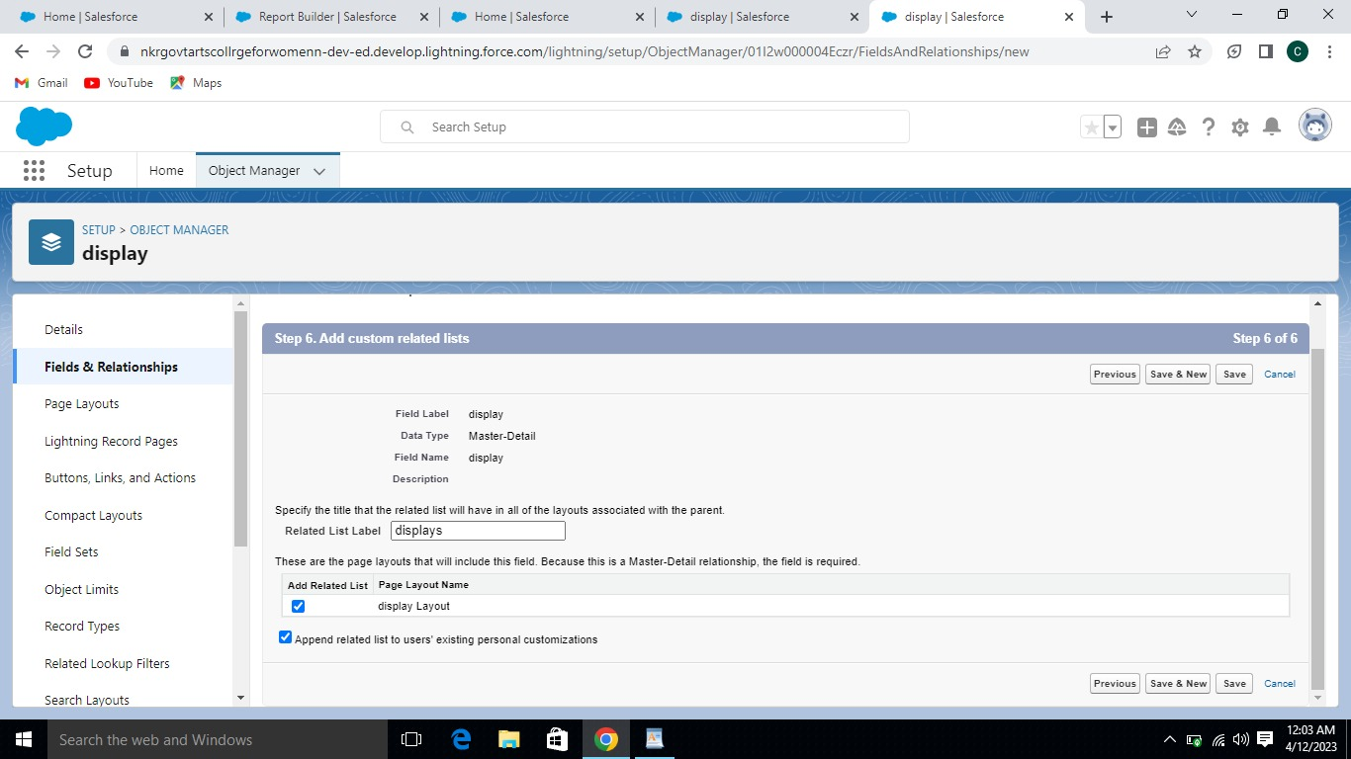

**Milestone -4 Application:**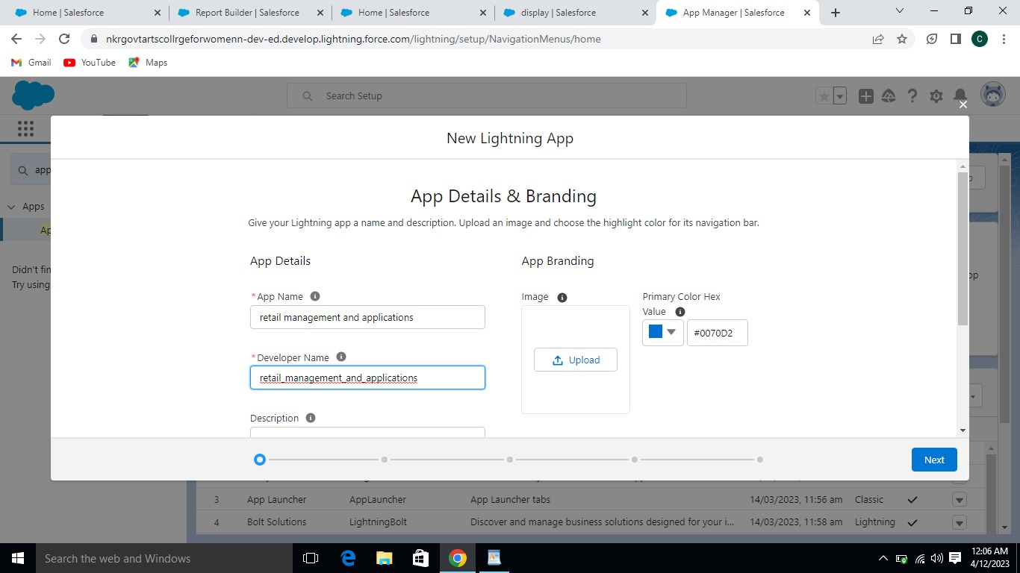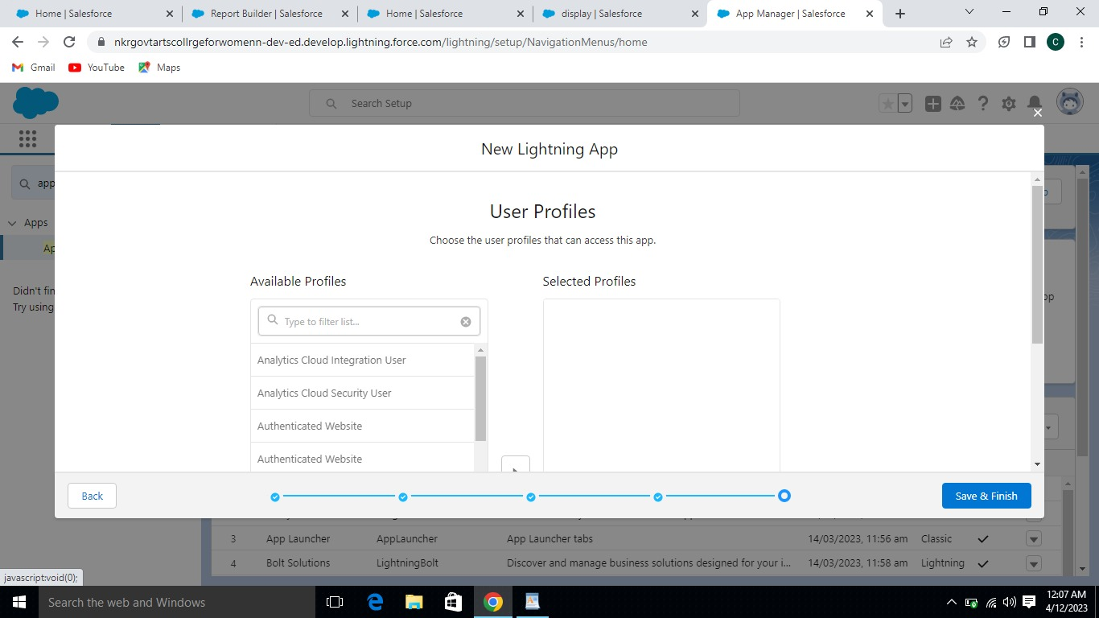

**Milestone-5 Layouts:**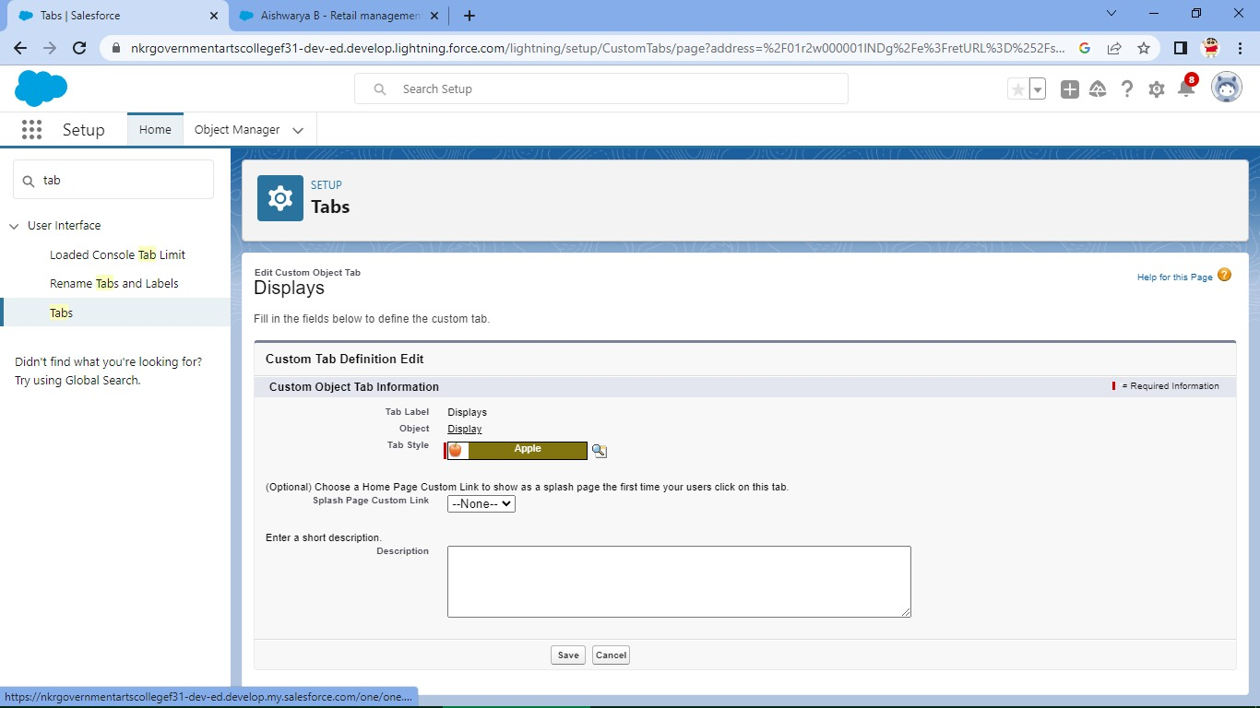

**Milestone-6 User:**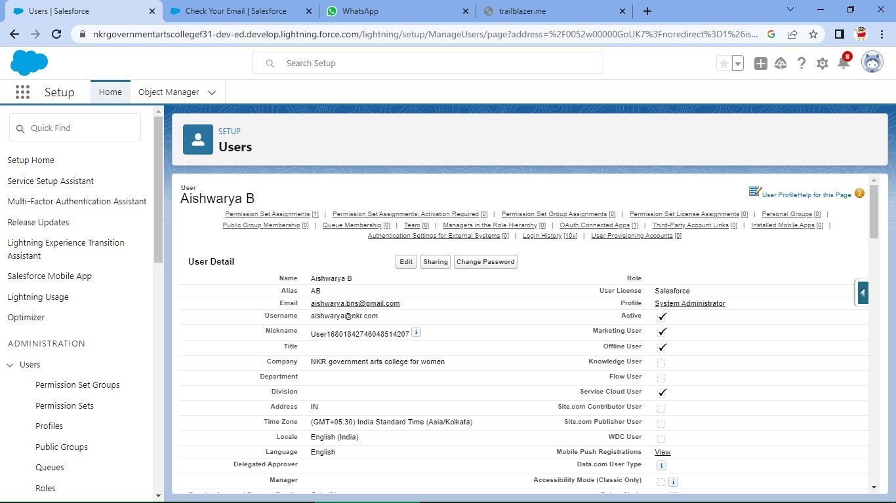

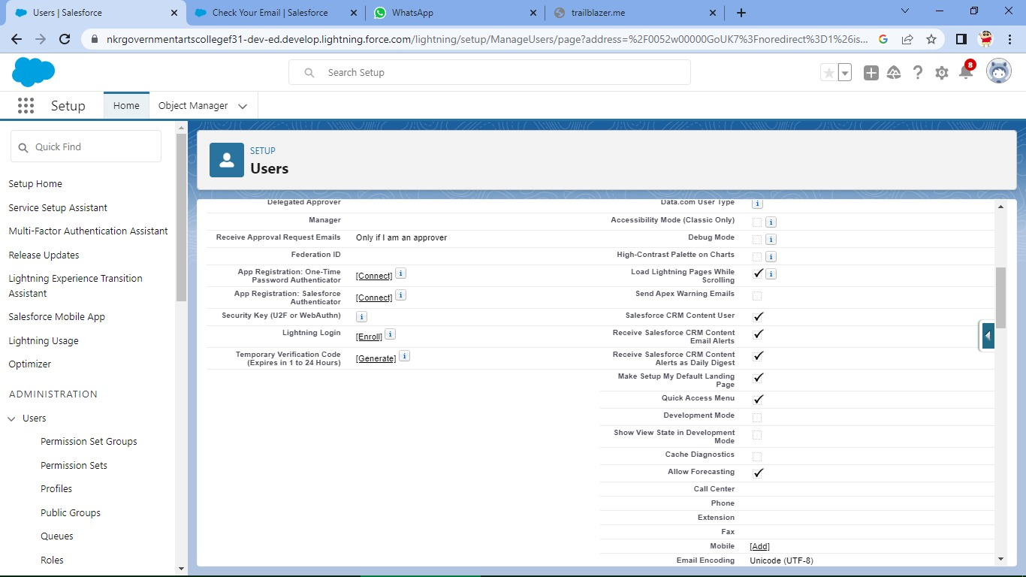

**Mileston-7 Validation Rules:**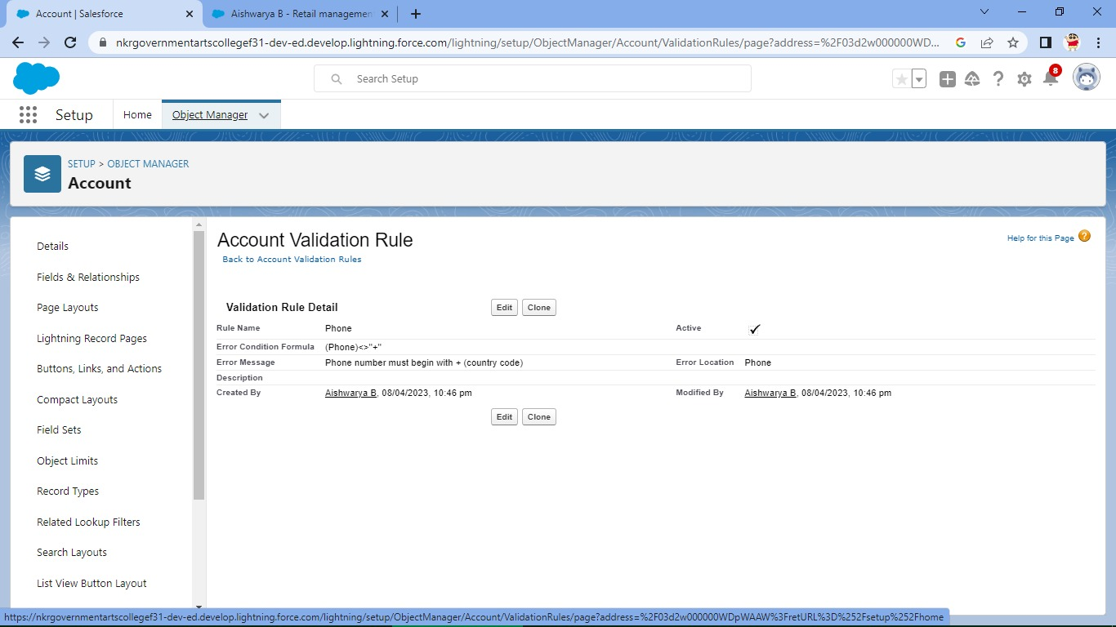

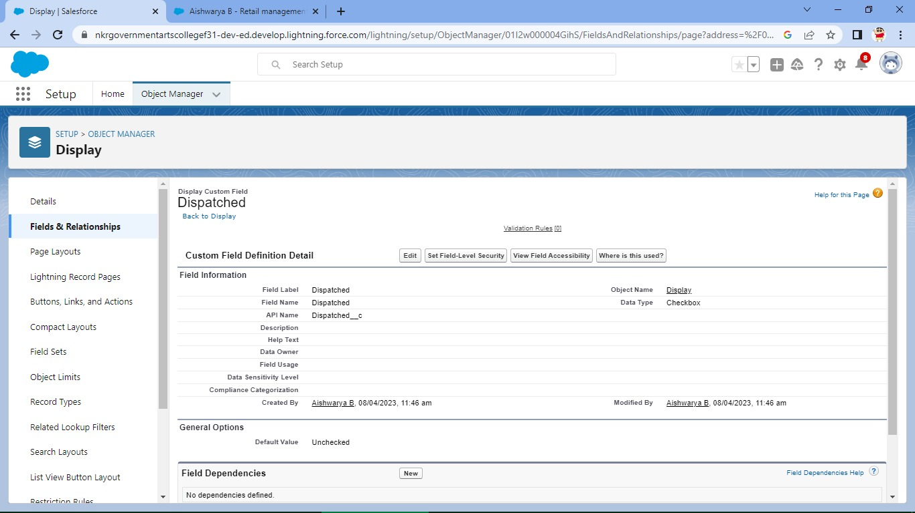

**Milestone-7 Reports:**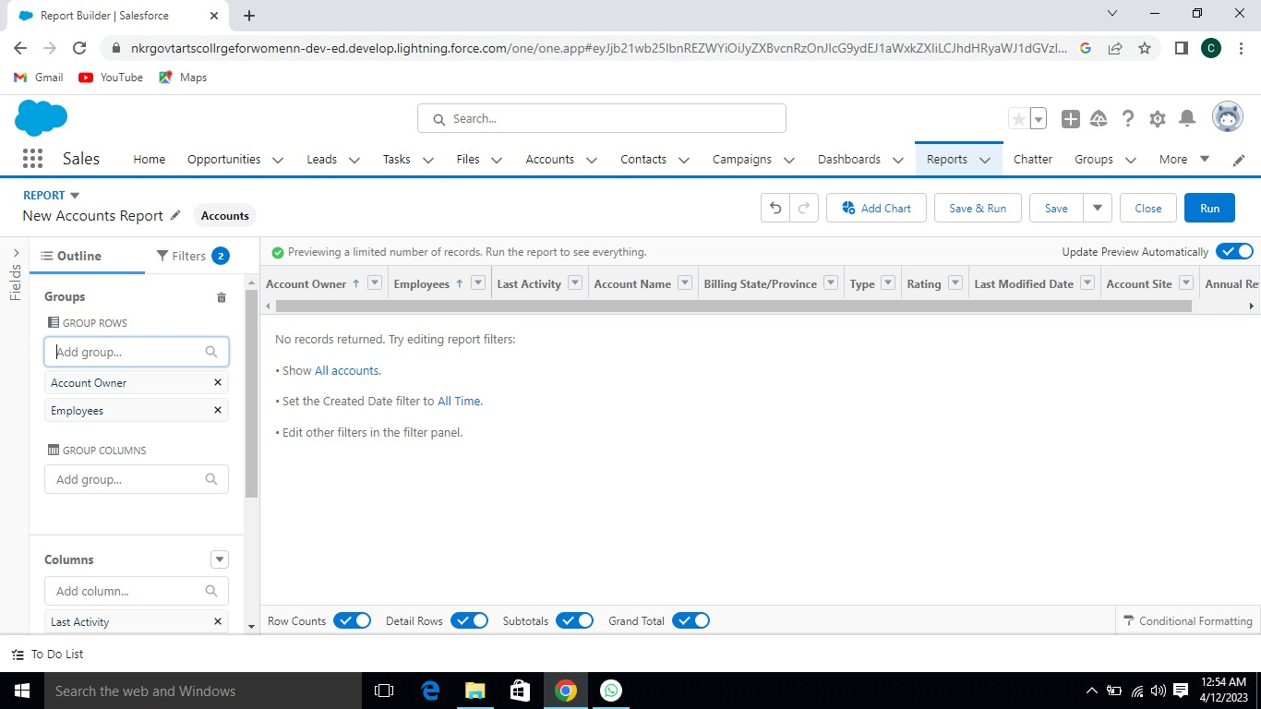

**Milestone-8 Dashboards**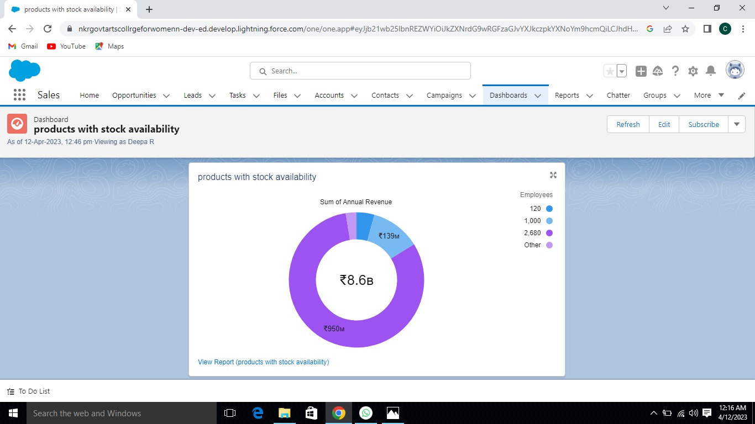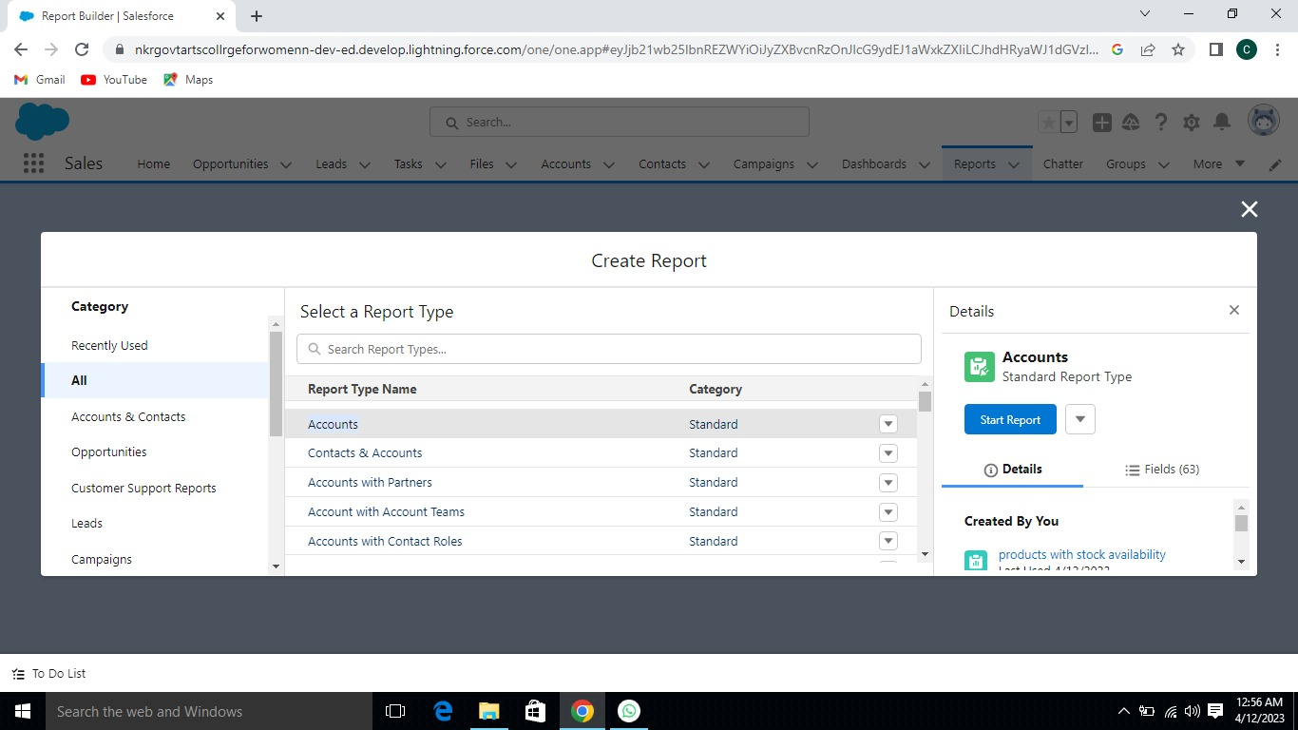

**4 Trailhead Profile Public URL**

**Team Lead-**[**https://trailblazer.me/id/aishb14**](https://trailblazer.me/id/aishb14) **(AISHWARYA B)**

**Team Member 1-**[**https://trailblazer.me/id/anitha4**](https://trailblazer.me/id/anitha4) **(ANITHA)**

**Team Member 2-**[**https://trailblazer.me/id/arthc**](https://trailblazer.me/id/arthc) **(ARTHI C)**

**Team Member3-**[**https://trailblazer.me/id/deepr63**](https://trailblazer.me/id/deepr63) **(DEEPA R)**

**5 ADVANTAGE & DISADVANTAGE**

|  |  |
| --- | --- |
| **ADVANTAGES** | **DISADVANTAGES** |
| Less Capital Requirement | High Marketing cost |
| More Profit Margin | Selling Skill Required |
| Credit Faculty | Very High Competition |
| Better Customer Relation | No Economies Of Buying |
| No Liability | It Requires Proper Location |

**6 APPLICATIONS**

* *Retail management optimize internal processes such as inventory management, offline and online storefronts, warehouse operations, payment and accounting, and human resources***.**
* *Retail management improves overall company cohesion. Retail store management improves customer experience and boosts customer satisfaction.*

**7 CONCLUSION**

* Retail management refers to the process of helping customers find products in your store.
* It includes everything from increasing your customer pool to how products are presented and how you fulfil a customer needs.
* In retail sector there is high staff turnover.
* Low wage long working hours and poor working conditions.

**8 FUTURE SCOPE**

* One can pursue different jobs in various fields in the retail sector as the retail sector as the job opportunities are never-ending.